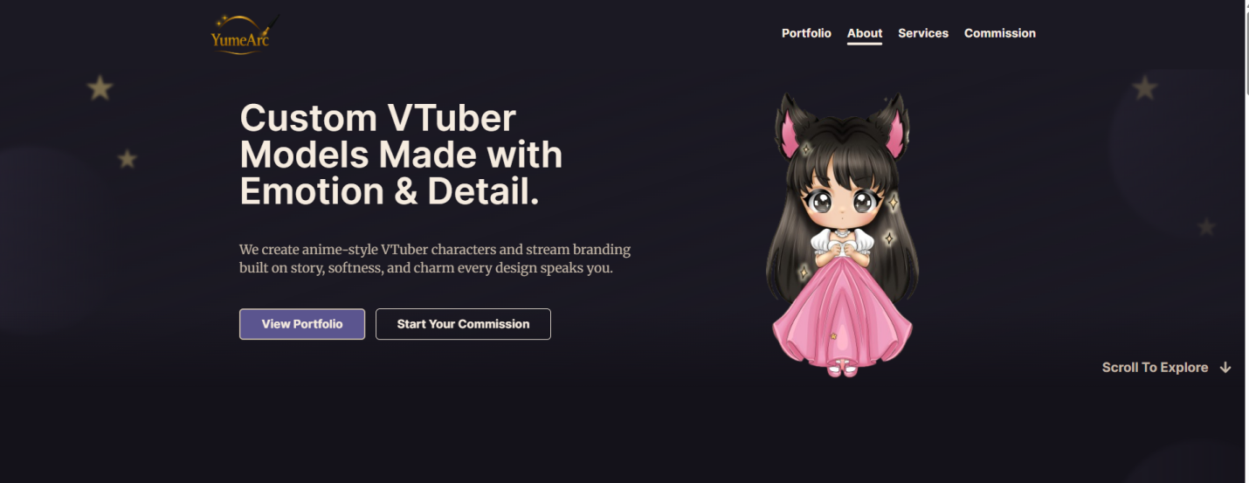
Headline: “Your VTuber shouldn’t look like everyone else’s.”
Subtext: “YumeArc designs custom anime-style models, PNGTubers, and stream visuals that feel like they belong to your character, your lore, and the world you’re building.”
Buttons:
See Our Work
Start a Project
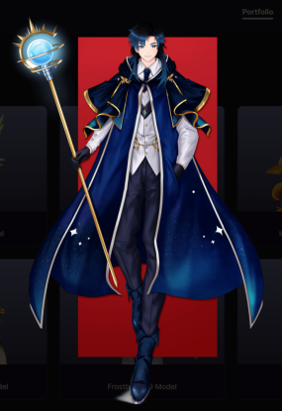
This image should appear on the right side instead of the chibi model

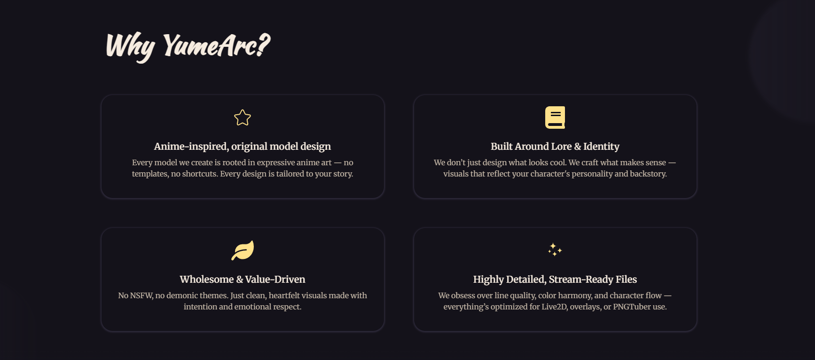

Headline: Built for creators who care about their character
Not just another anime design
“We build around the details that make your character feel like yours: the colors, mood, references, personality, and story behind the design.”
Lore comes first
“Whether you have a full backstory or just a rough idea, we shape the visuals so your character feels connected, not random.”
Clean, creator-safe style
“We focus on expressive, stream-friendly anime visuals without NSFW or extreme themes, so your character feels safe to grow a community around.”
Made for actual stream use
“Models, PNGTubers, panels, overlays, and emotes are designed to look good where your audience actually sees them: on stream, on your profile, and across your socials.”

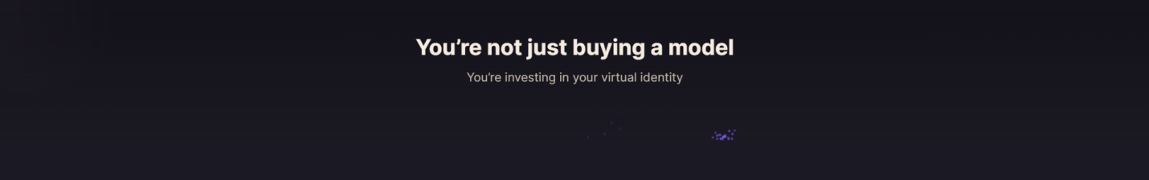
A model is more than a drawing. It’s how people remember you.
Your colors, silhouette, expressions, panels, and stream visuals all shape how your audience recognizes you. We bring those pieces together so your character feels consistent everywhere your community sees you.

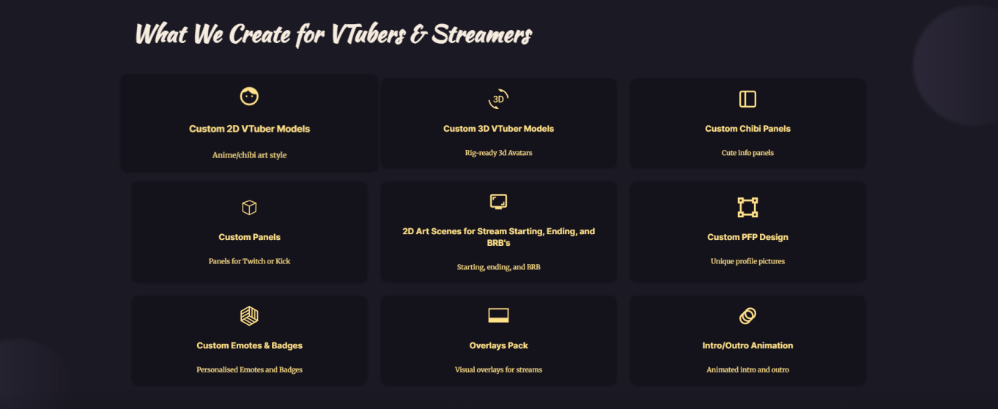

Section heading: “Everything your VTuber identity needs”
Subtext: From your model to your stream visuals, we design assets that feel connected to your character and community.
2D VTuber Models
Custom anime-style models built around your character.
3D VTuber Models
Stylized 3D models for a more interactive stream presence.
PNGTuber Designs
Expressive PNG art for creators not ready for a full model yet.
Chibi Stream Panels
Cute panels for About, Rules, Credits, Donate, and more.
Custom Stream Panels
Clean panels matched to your character and theme.
Starting / BRB / Ending Screens
Stream scenes that set the mood before and between moments.
PFP Designs
Profile art made to feel recognizable across platforms.
Emotes & Badges
Small expressions your community can actually use.
Stream Overlay Pack
Overlay designs that match your model and stream vibe.
Intro / Outro Animation
Short animated moments for openings, debuts, and transitions.

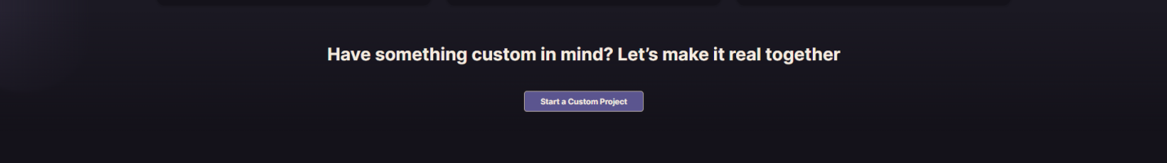

Headline: “Have a character idea that needs a custom approach?”
Button: “Start a Custom Project”

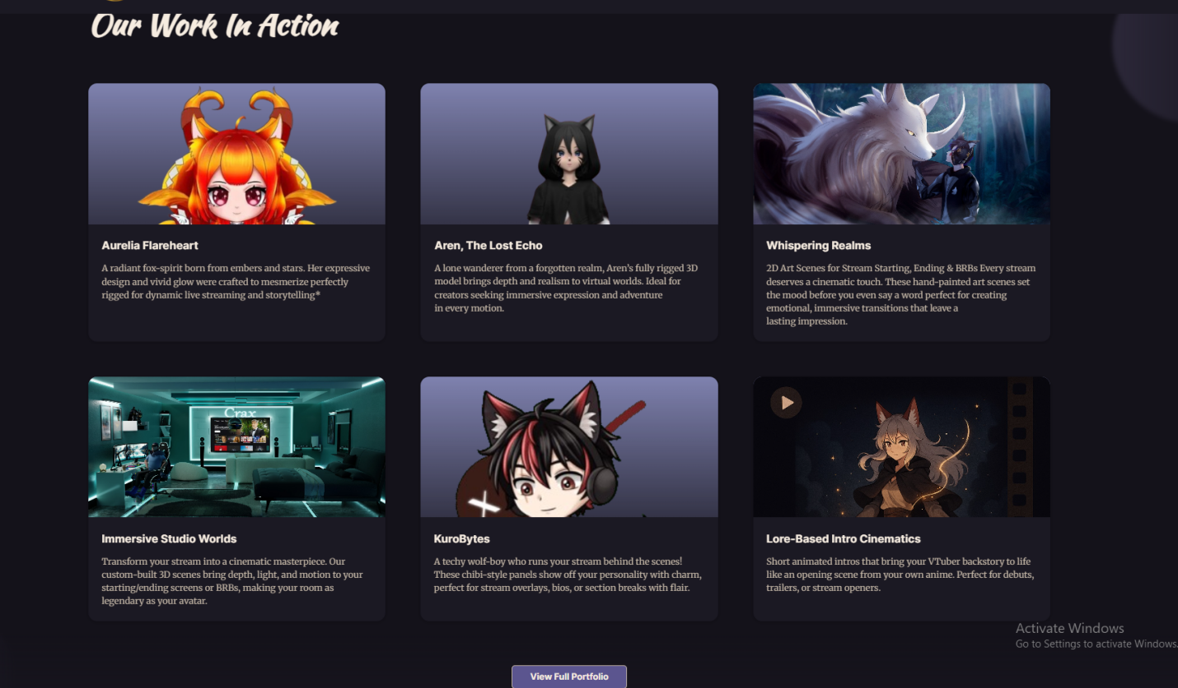

Headline: “Featured Work”
Subtext: “A quick look at models, panels, and stream visuals shaped around each creator’s character.”

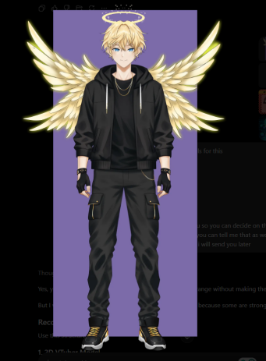
Main heading: Halo Angel Model
Description: A soft angel-inspired Live2D model with gentle colors, clean outfit details, and a friendly design made to feel memorable across stream and socials.

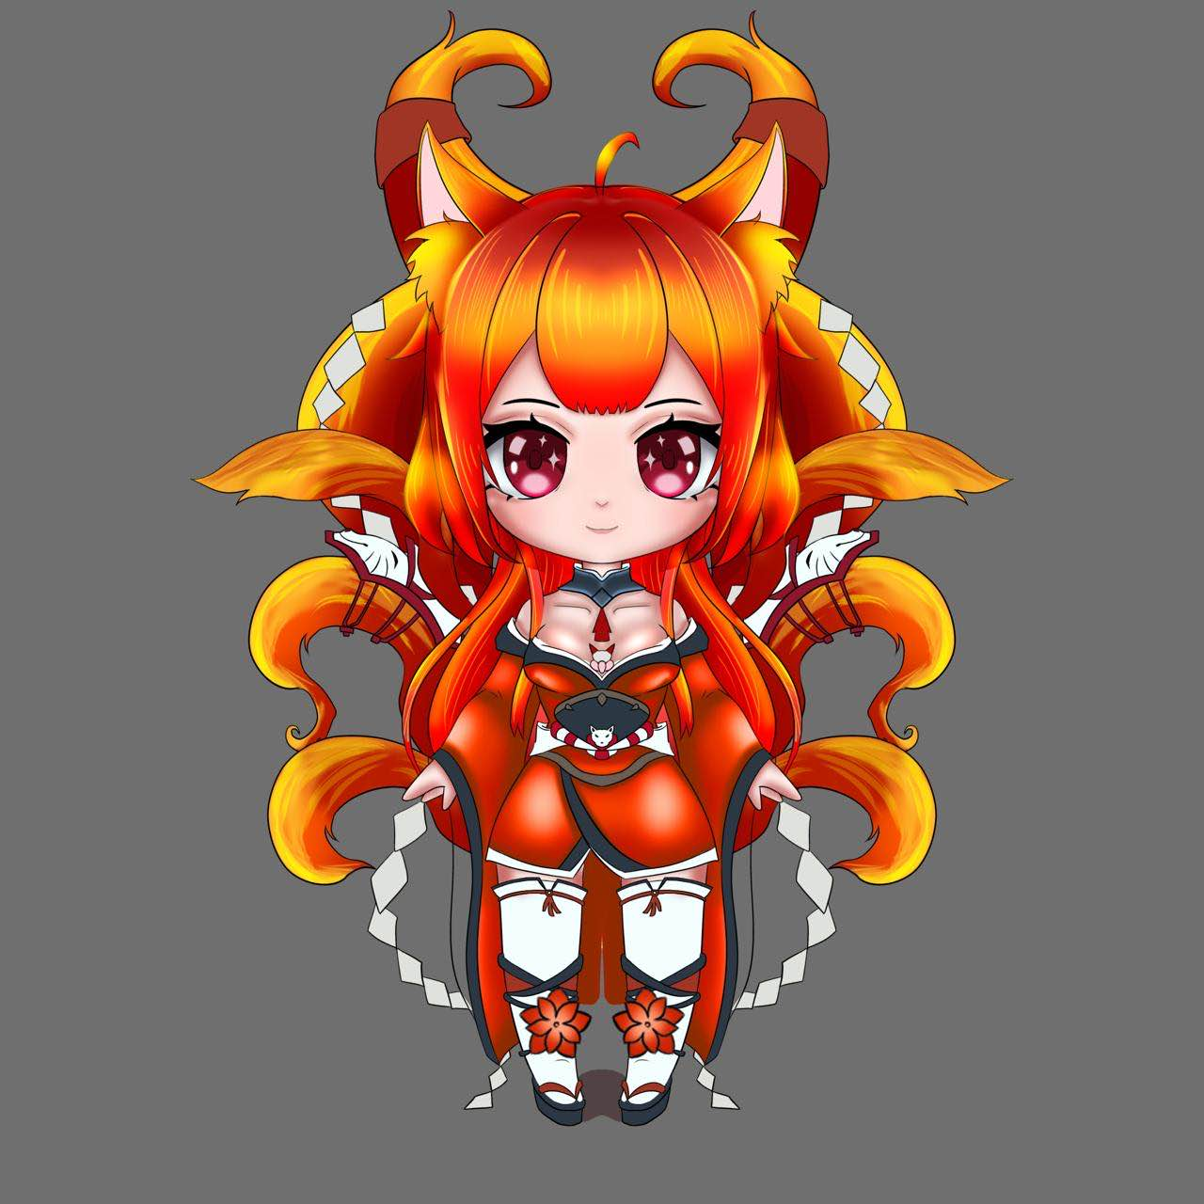
Main heading: Orange Fox Chibi
Description: A cute fox-inspired chibi model with bright colors, playful expressions, and smooth movement made for stream reactions and personality moments.

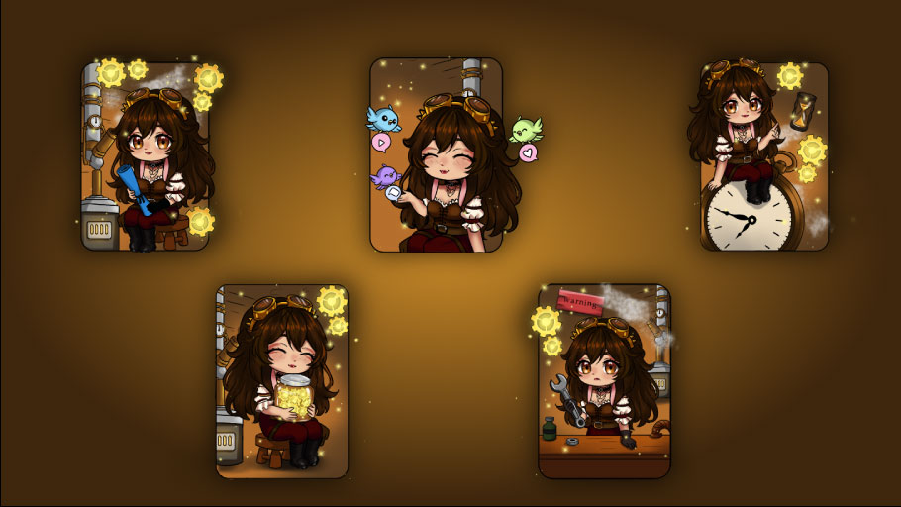
Main heading: Steampunk Panel Set
Description: A chibi-style panel set with warm steampunk details, realistic scene backgrounds, and clear sections made to keep the channel feeling personal and polished.
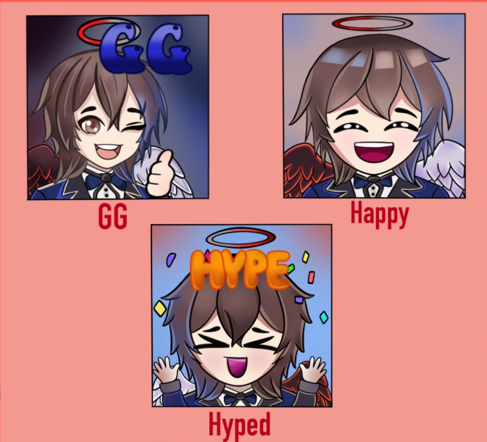

Main Heading: GG / Happy / Hyped Emotes
Description: A set of expressive chat emotes made for quick reactions, community moments, and small character details your audience can actually use.

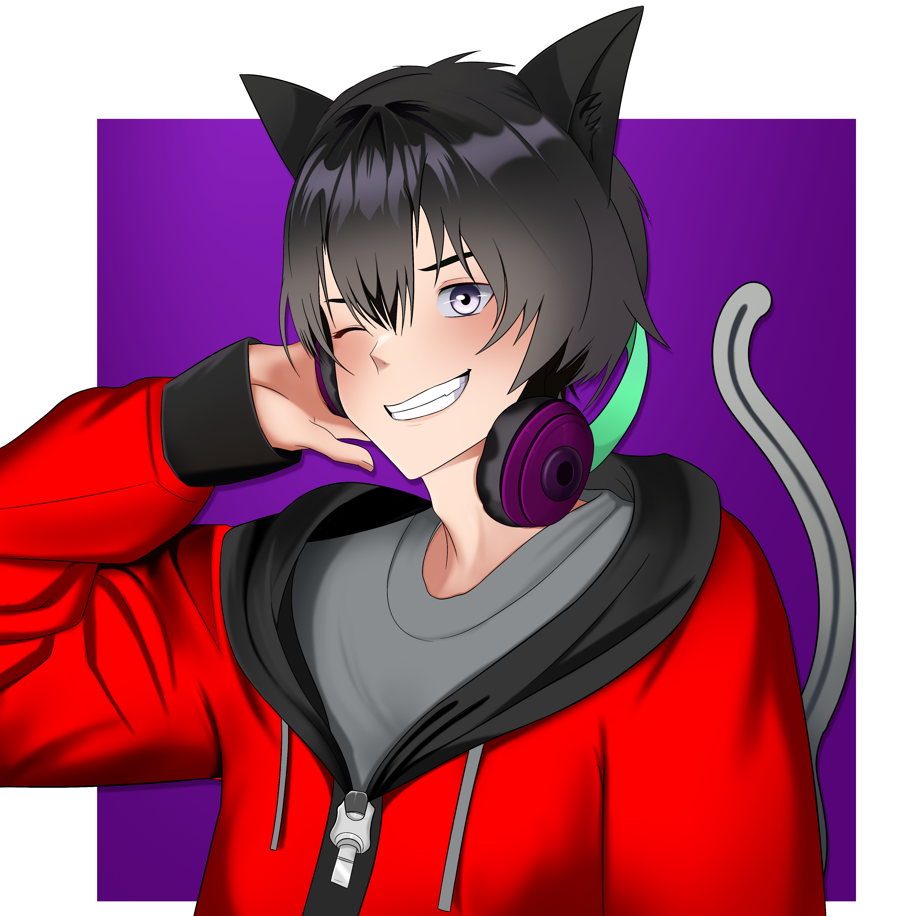
Main Heading: Red Hoodie Catboy PFP
Description: A clean character PFP with sharp catboy details, bold red accents, and a readable expression made to stand out across profiles and socials.

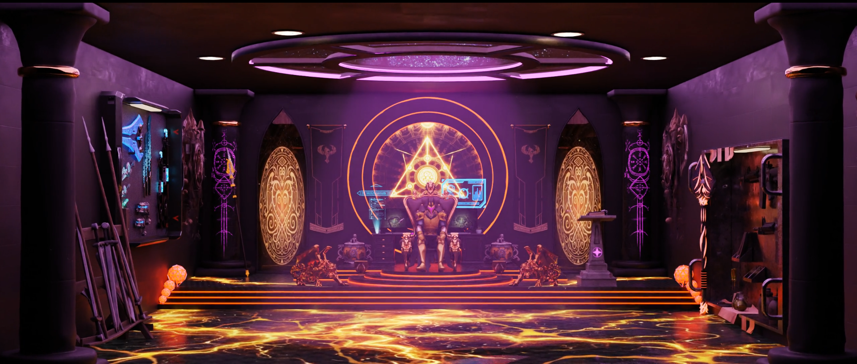
Main Heading: Cinematic Stream Intro
Description: A cinematic 3D scene with moody lighting, room details, and a slow reveal made for stream openings, debuts, or lore moments.

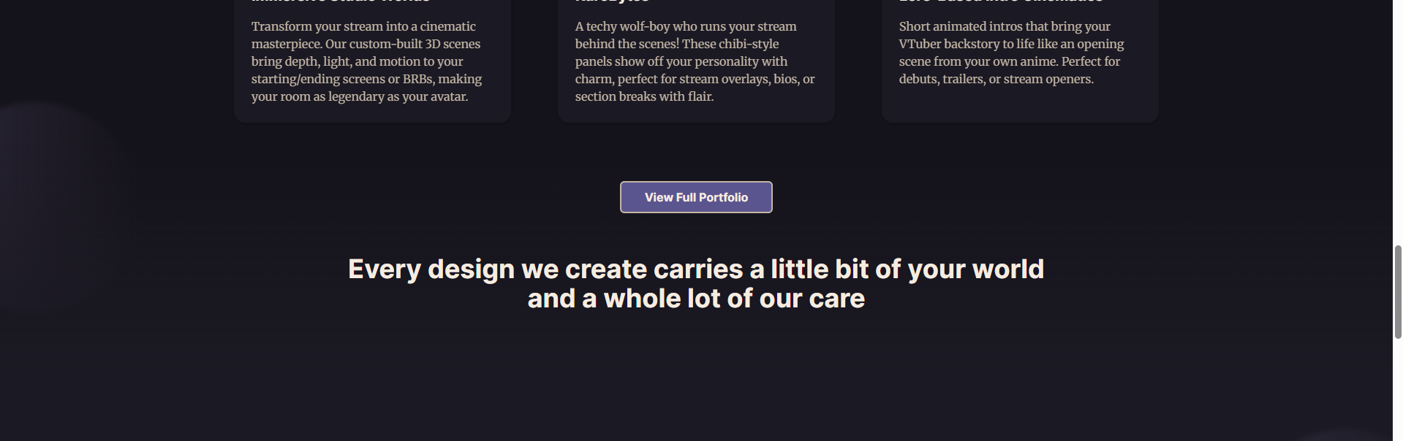
Remove this Line

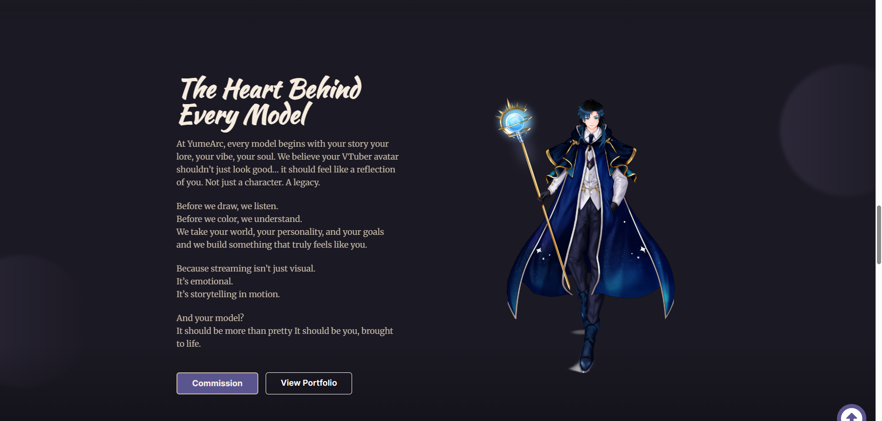

Main Heading: Still figuring out your character?
Description:
That’s normal. Some creators come with pages of lore. Some come with a messy idea, a few references, or just a feeling they can’t fully explain yet.
Maybe you know the personality but not the outfit. Maybe you have the backstory but no clear visual direction. Or maybe your current model is close, but something still feels missing.
We help turn those pieces into a clearer direction: the mood, colors, outfit details, expressions, panels, and stream visuals that actually fit the character you’re trying to build.
So even if your idea isn’t fully shaped yet, we can help make it feel more like you.
Button: Start a Project

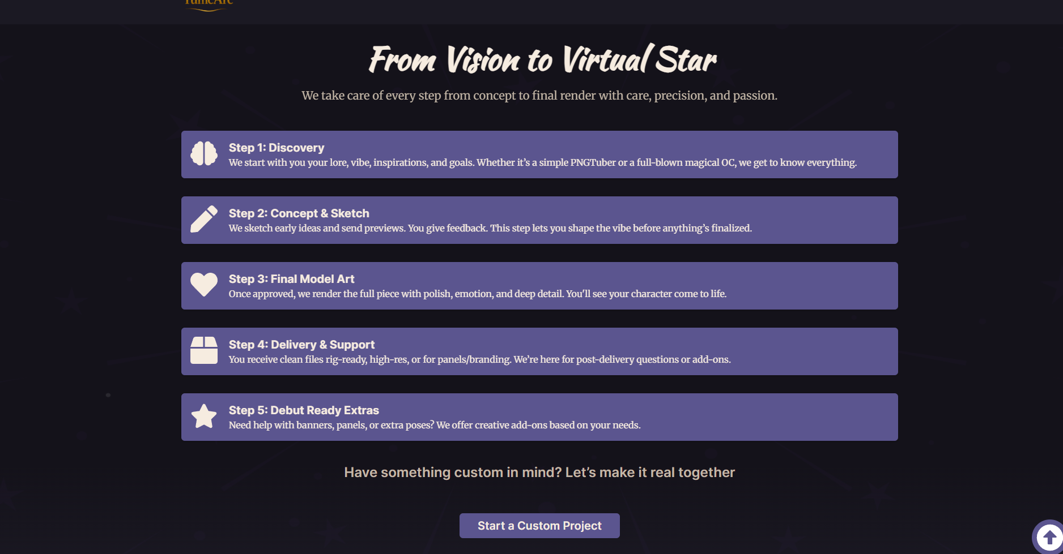
Heading: From rough idea to stream-ready visuals
Step 1: We explore the idea
We talk through your lore, mood, references, and character goals while also helping you clarify the direction if things still feel messy or unfinished.
Step 2: We shape the concept
We narrow the look, outfit details, expressions, and overall visual style so the character starts feeling more clear and consistent.
Step 3: Rough sketch first
We create an initial sketch so you can see the pose, structure, outfit flow, and main design direction before we move further.
Step 4: Color, shade, and refine
Once the sketch feels right, we move into clean lines, colors, shading, and the final visual details.
Step 5: Final files and stream-ready delivery
We prepare clean exports and final files so your model, panels, emotes, or stream assets are ready to use across your platforms.

Heading: Have a character idea that needs a custom approach?
Button: Start a Custom Project
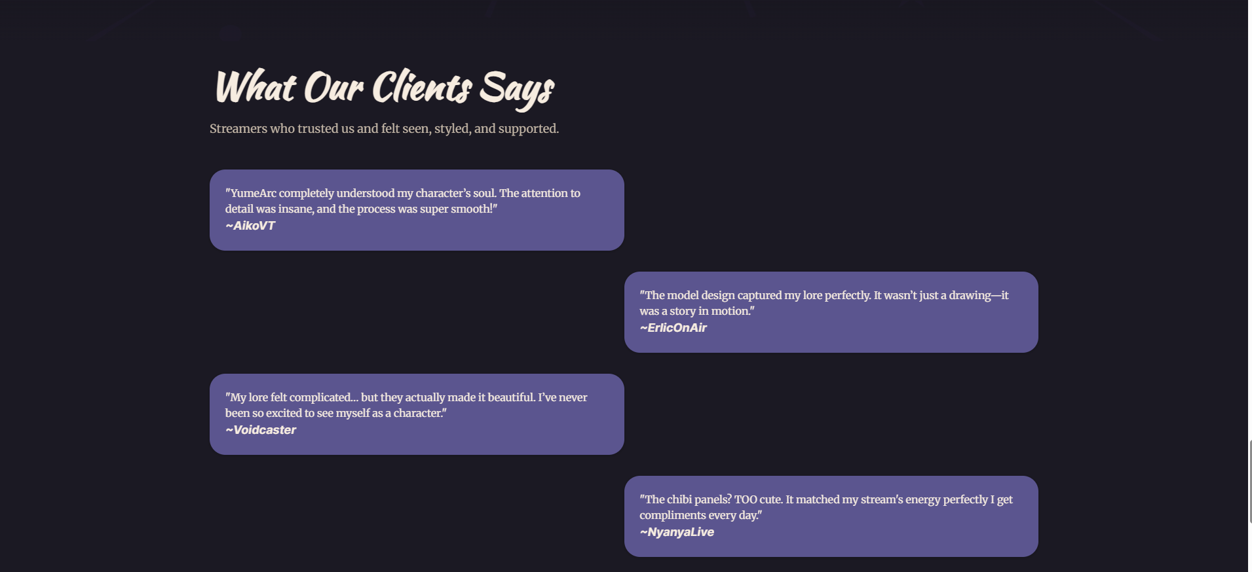
Main Heading: What creators usually come to us with

Description: Most ideas don’t start perfectly clear. That’s normal. We help turn scattered lore, references, and stream goals into visuals that feel connected.

“I have lore, but no clear visual direction.”
We help turn the story into colors, outfit details, expressions, and stream assets that actually make sense together.

“My current model is okay, but it doesn’t fully feel like me.”
We look at what’s working, what feels off, and what could make the character stronger without losing the parts you still like.

“I need panels, emotes, or stream visuals that match my character.”
We design supporting assets so your channel feels consistent instead of looking like random pieces from different places.

“I have references, but I don’t know how to explain the vibe.”
That’s fine. We help shape the mood, theme, and visual direction before moving into the artwork.

Button: Start a Project
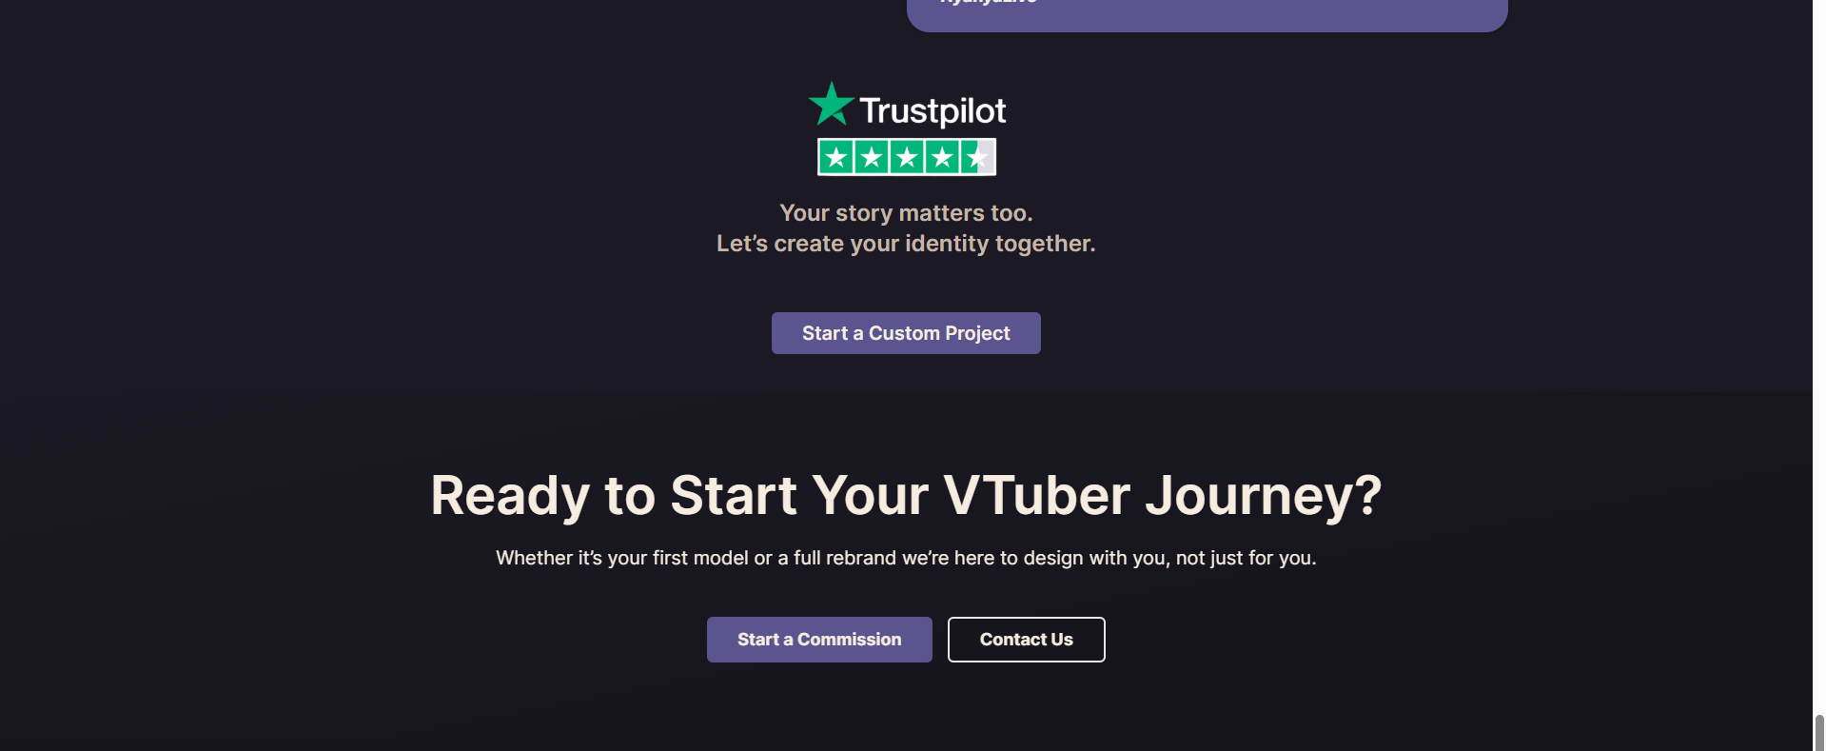
Main Heading: Trusted by creators building their next identity
Description: See real feedback from creators who worked with YumeArc on custom models, stream visuals, and character-focused assets.
Buttons:
Check Trustpilot Reviews
Start a Project

ABOUT SECTION:
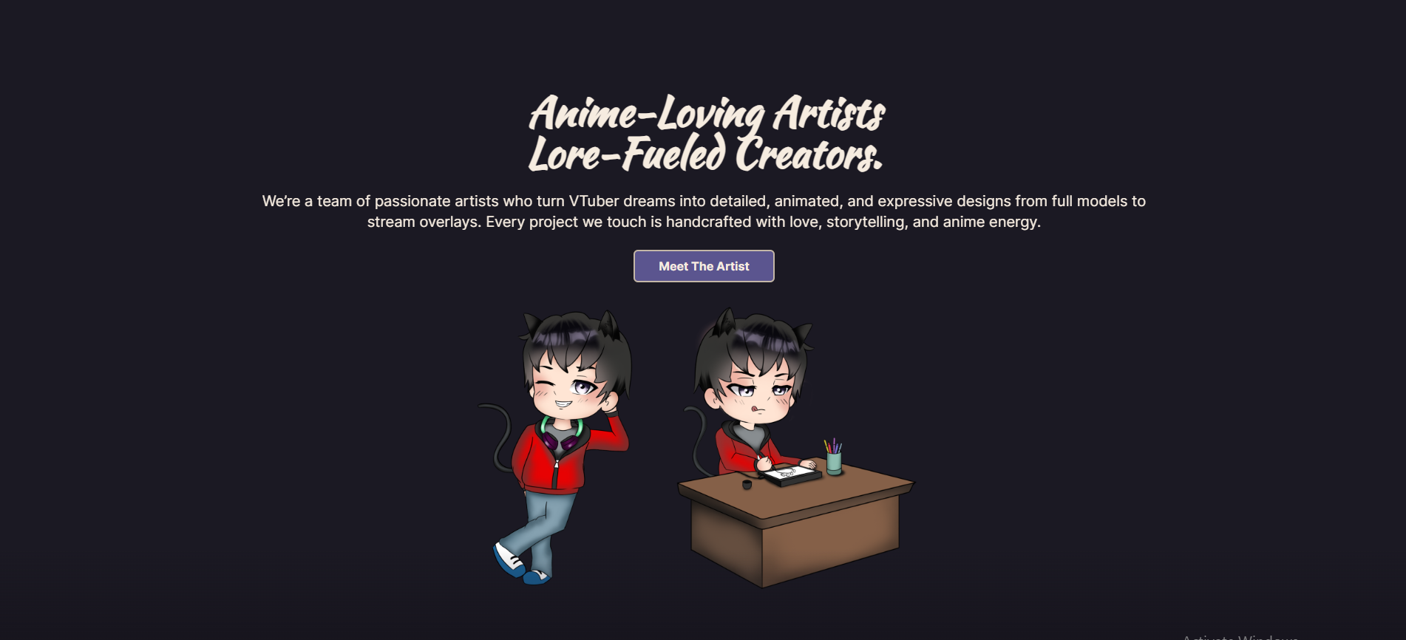
Headline: We’re artists who care about the character behind the model.
Description: YumeArc is a small creative team creating VTuber models, PNGTubers, custom chibi panels, emotes, and stream visuals that feel connected to each creator’s lore, personality, and direction.
Button: Meet the Team
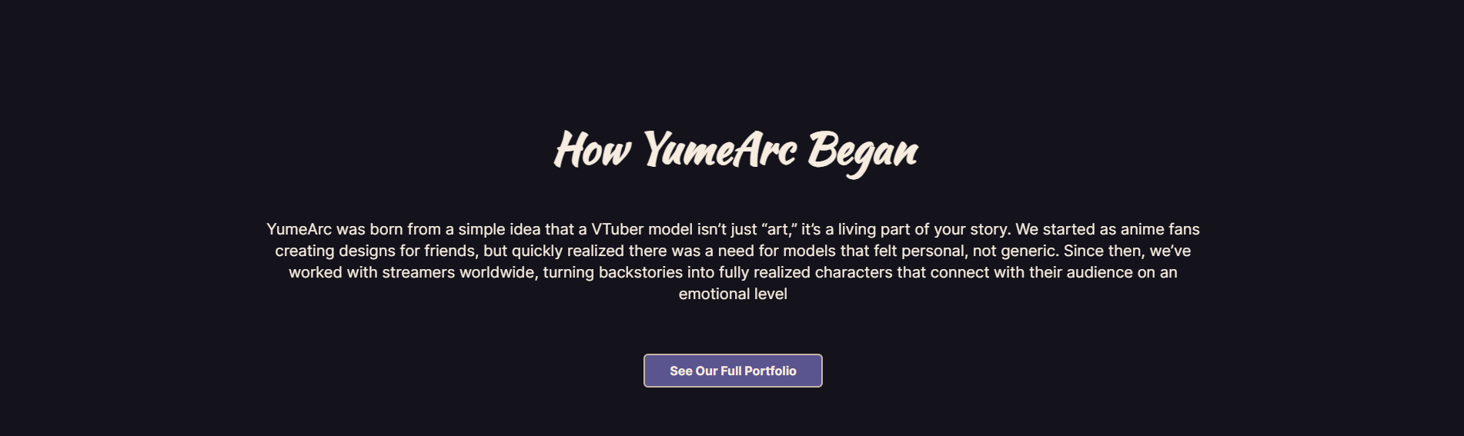
Heading: How YumeArc began
Description: YumeArc started from something we kept seeing with creators: they had lore, personality, references, and ideas in their head, but didn’t always know how those things should look visually.
A character can have a strong backstory, but still feel hard to turn into colors, outfits, expressions, panels, or stream scenes. That’s where we wanted YumeArc to be different.
We don’t just ask what you want drawn. We listen to the character you’re trying to build, help clarify the direction, and then create visuals that feel personal, connected, and easier for your audience to remember.
Button: See Our Work
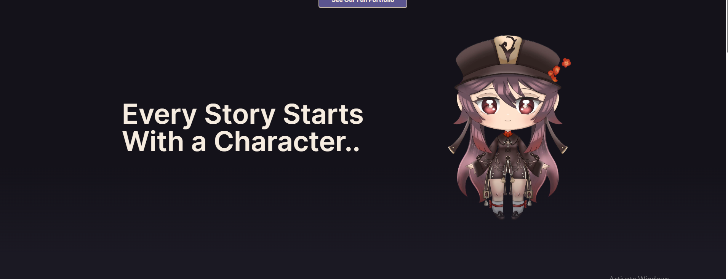
Remove this section

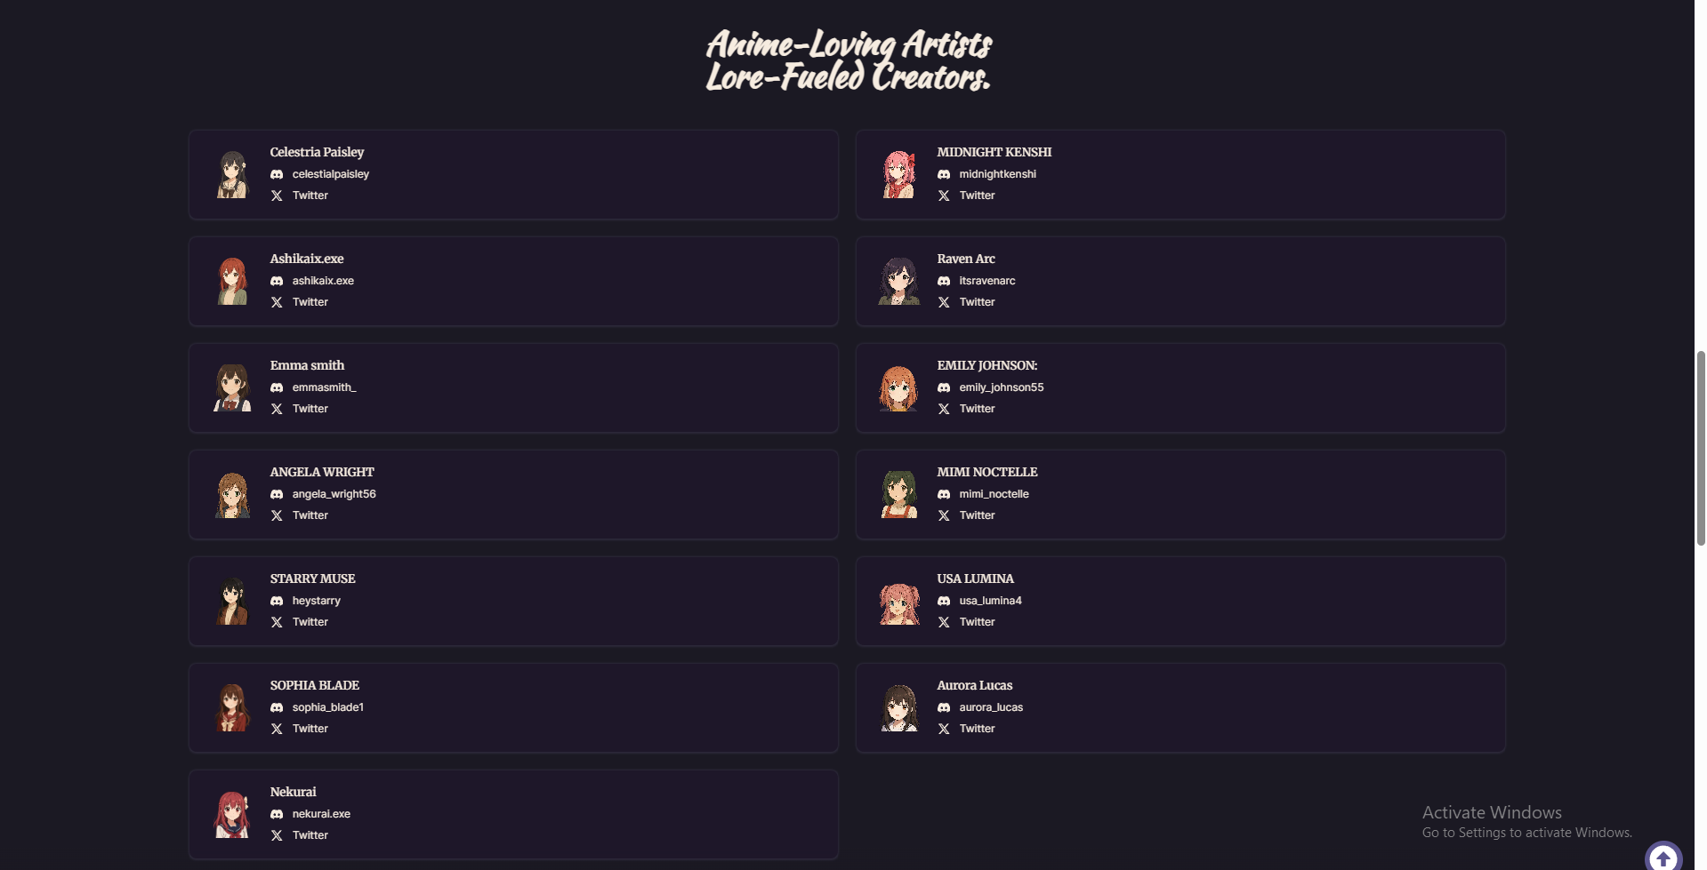
Heading: Official YumeArc Team Members
Subtext: These are the only official people working under YumeArc. If someone contacts you outside this list, please check with us through our official Discord or X before sharing project details or placing an order.
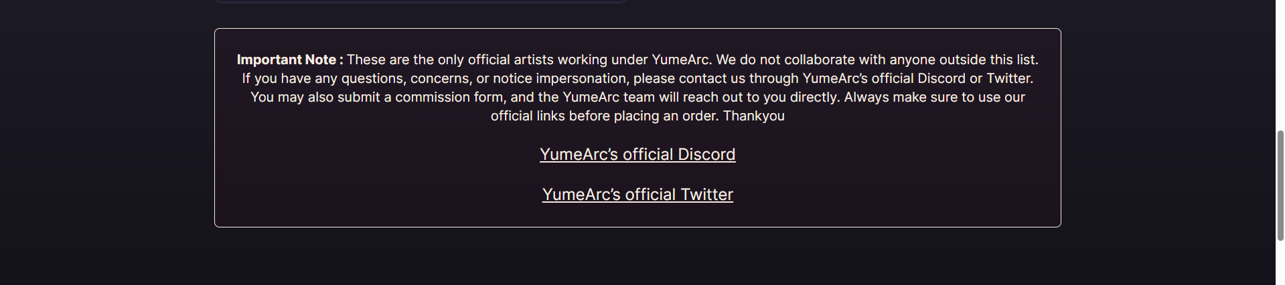
Important note: These are the only official people working under YumeArc. If someone contacts you claiming to be from YumeArc and they are not listed here, please check with us before sharing project details or making any payment.
For questions, impersonation concerns, or commission help, use our official Discord or X / Twitter links below.
Links:
YumeArc Official Discord
YumeArc Official X / Twitter
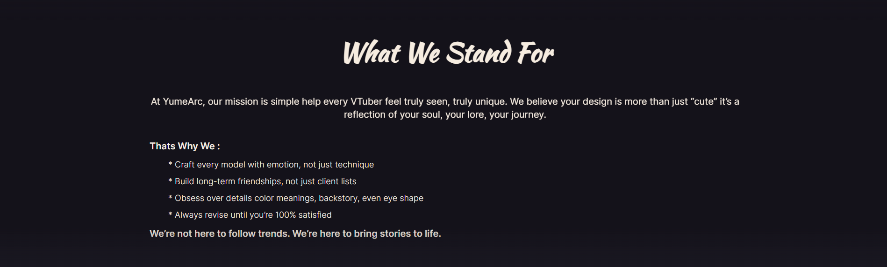
Heading: What we care about
Originality over templates
We don’t want your model or stream assets to feel like something anyone else could use. The goal is to make the design feel personal to your character.
Story before style
Pretty art matters, but the lore, mood, personality, and background of the character should guide the visual direction.
Clean, creator-safe work
We focus on expressive anime-style visuals without NSFW or extreme themes, so the work feels safe to build a community around.
Details that actually matter
Colors, outfit choices, expressions, panels, and small visual cues should all support the same character identity.

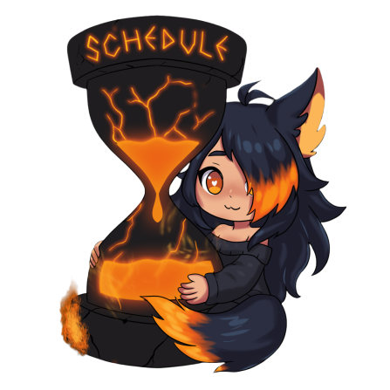
This image on the left side

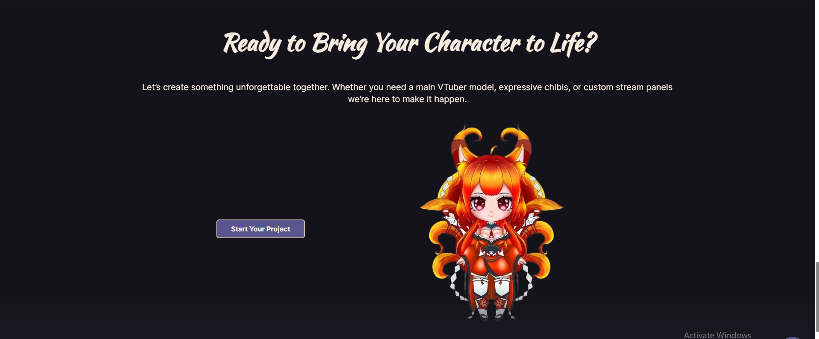
Heading: Ready to shape your character with us?
Description: Bring the lore, references, messy ideas, or just the feeling you want your character to have. We’ll help turn it into visuals that feel connected, personal, and ready for stream.
Button: Start a Project

Services Page
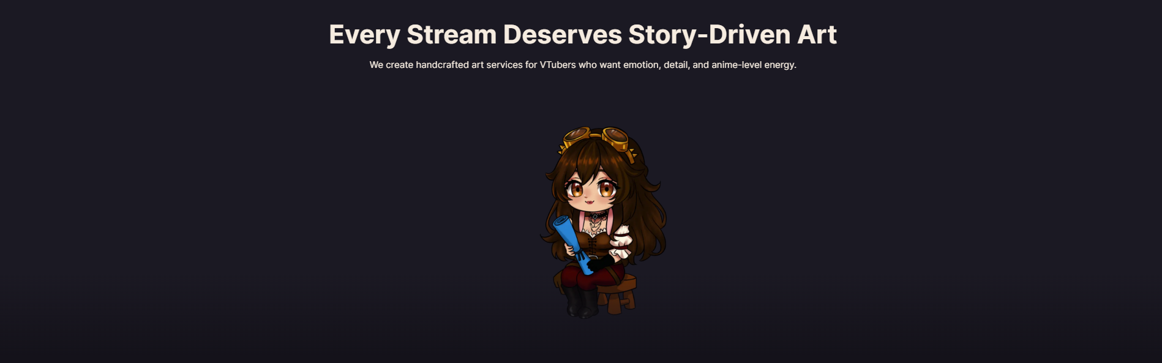
Left side text:
Heading: Services built around your character, not just your order.
Description: From Live2D models and PNGTubers to chibi panels, emotes, overlays, and stream scenes, we create assets that feel connected to your lore, personality, and the way you want to show up online.
Button: Explore Services
Right side image:

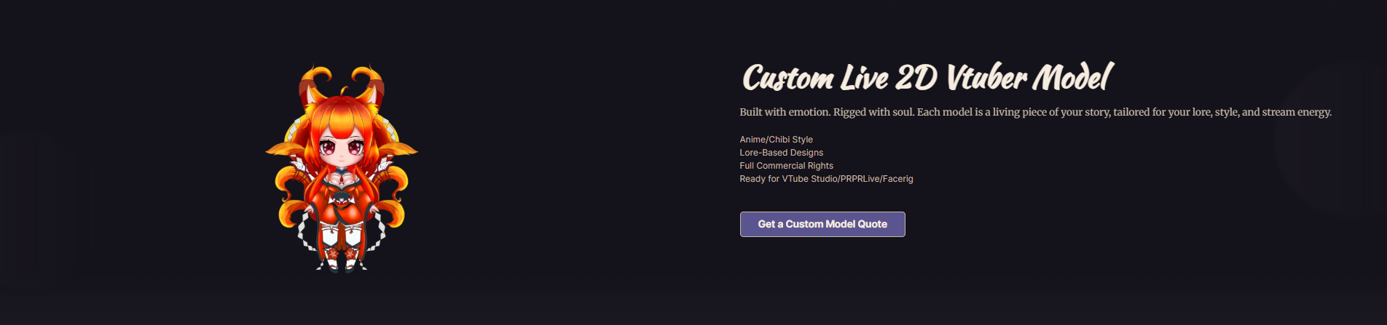
Heading: Custom Live2D VTuber Models
Description: A custom Live2D model built around your character’s lore, personality, colors, and stream presence. Whether your idea is fully planned or still messy, we help shape the visual direction before moving into the final model.

Bullets:
Built around your lore and references
Custom outfit, colors, expressions, and character details
Live2D-ready model art and rigging options
Prepared for VTube Studio and stream use
Button: Start a Live2D Model

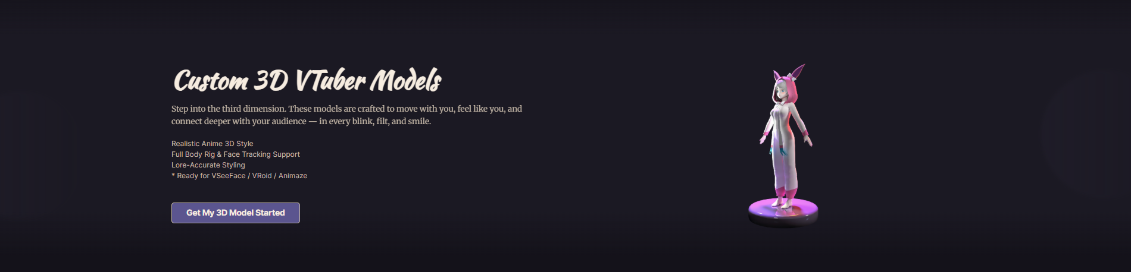

Heading: Custom 3D VTuber Models
Description: A stylized 3D VTuber model designed around your character’s theme, outfit, colors, and stream personality. Built for creators who want a more flexible model that can move naturally on stream.
Custom outfit, colors, and character styling
Full-body movement and face tracking support
Built around your lore and visual direction
Prepared for VSeeFace, VRoid, or Animaze use
Button: Start a 3D Model

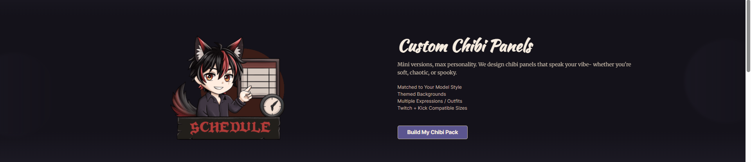

Heading: Custom Chibi Panels
Description: Chibi-style stream panels designed around your character, theme, and channel sections. Each panel can have its own small scene, expression, or background so your profile feels more personal than a basic text panel.
Matched to your model, outfit, and theme
Scene-based backgrounds for each section
Custom expressions, poses, and small details
Sized for Twitch, Kick, Discord, or socials
Button: Build My Chibi Panels

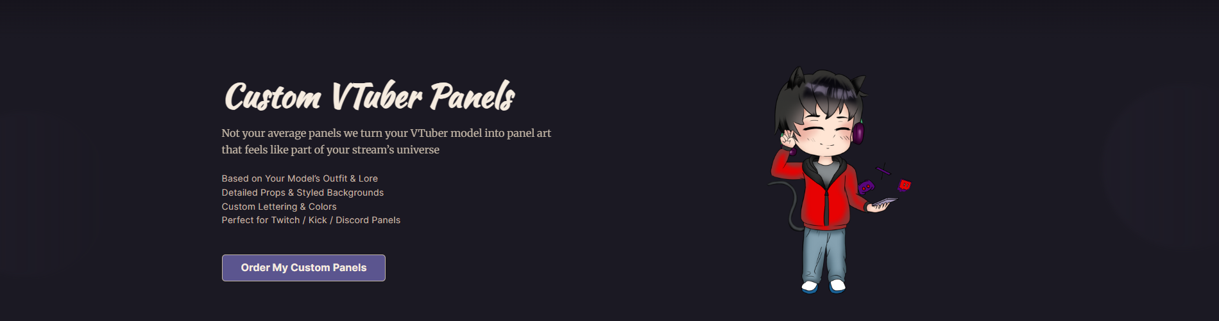
Remove this section

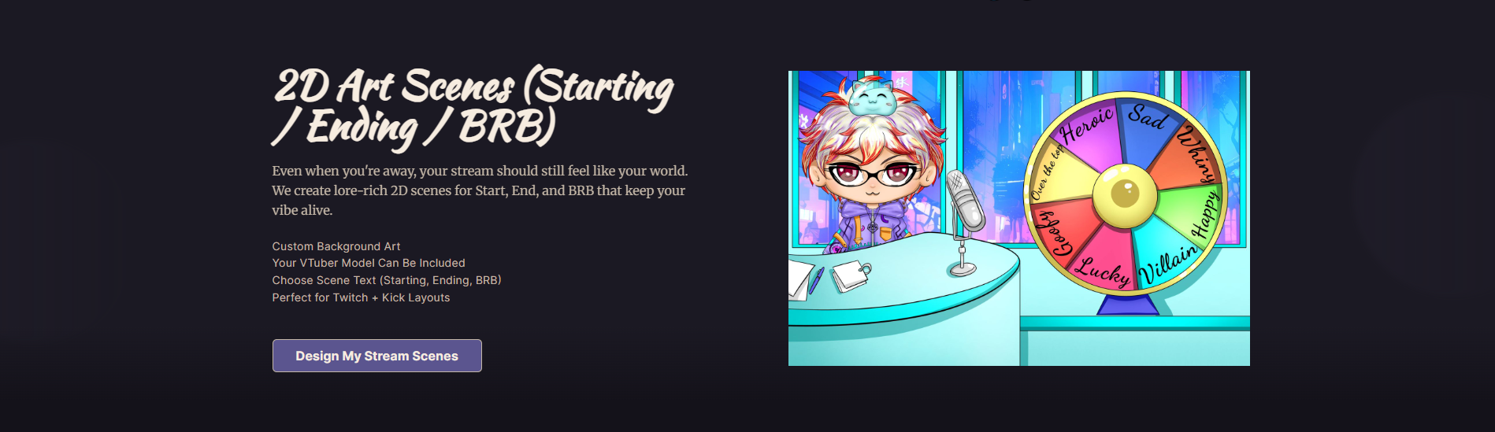
Heading: Starting, BRB & Ending Screens
Description: Custom stream scenes made to match your character’s world, mood, and channel style. Instead of using a plain screen, these visuals help your stream feel more complete before, during, and after you go live.
Bullets:
Designed around your character’s theme and lore
Custom scenes for Starting, BRB, Ending, or Offline screens
Can include cozy, fantasy, spooky, soft, or energetic moods
Sized for Twitch, YouTube, Kick, and stream overlays
Button: Create My Stream Screens
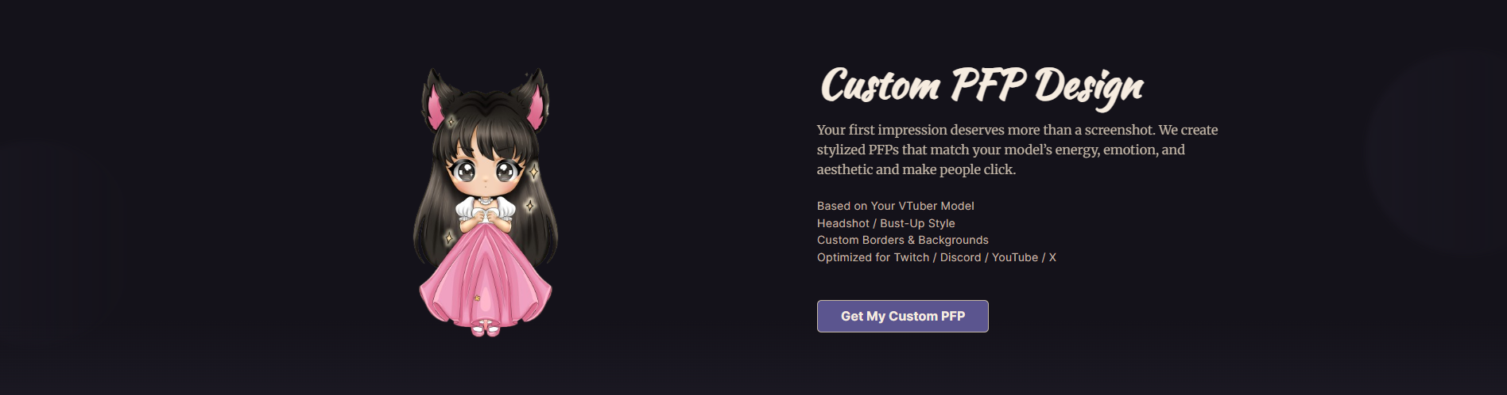
Heading: Custom PFP Design
Description: Profile art designed to make your character easy to recognize across Twitch, Discord, X, YouTube, and other socials. We focus on the expression, colors, and small details that still read clearly in a tiny profile circle.
Bullets:
Designed around your character’s look and personality
Clear expression and readable silhouette
Sized for profiles, socials, and community spaces
Can be soft, cute, chaotic, dark, cozy, or fully themed
Button: Create My PFP
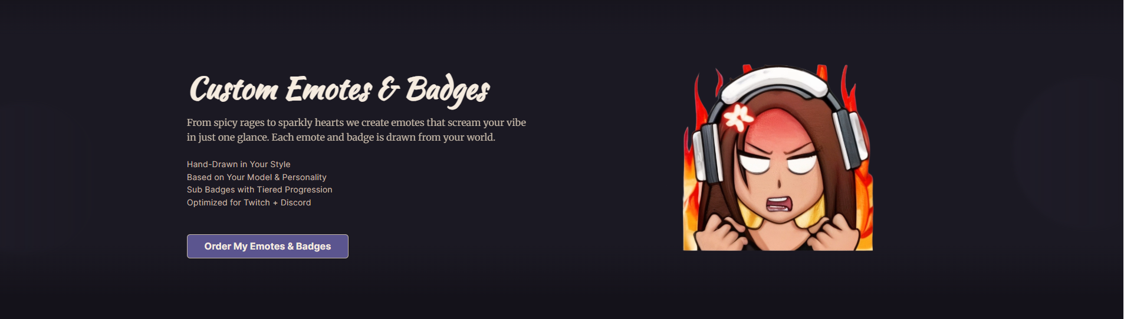
Heading: Custom Emotes & Badges
Description: Expressive emotes and badges made for chat reactions, community moments, and the little inside jokes that make your stream feel alive. We design them to match your character’s expressions, colors, and personality so they feel like part of your identity.
Bullets:
Custom expressions based on your character
Emotes for hype, laughs, reactions, alerts, and community moments
Subscriber badges or loyalty icons matched to your theme
Sized and prepared for Twitch, Discord, YouTube, or Kick
Button: Create My Emotes
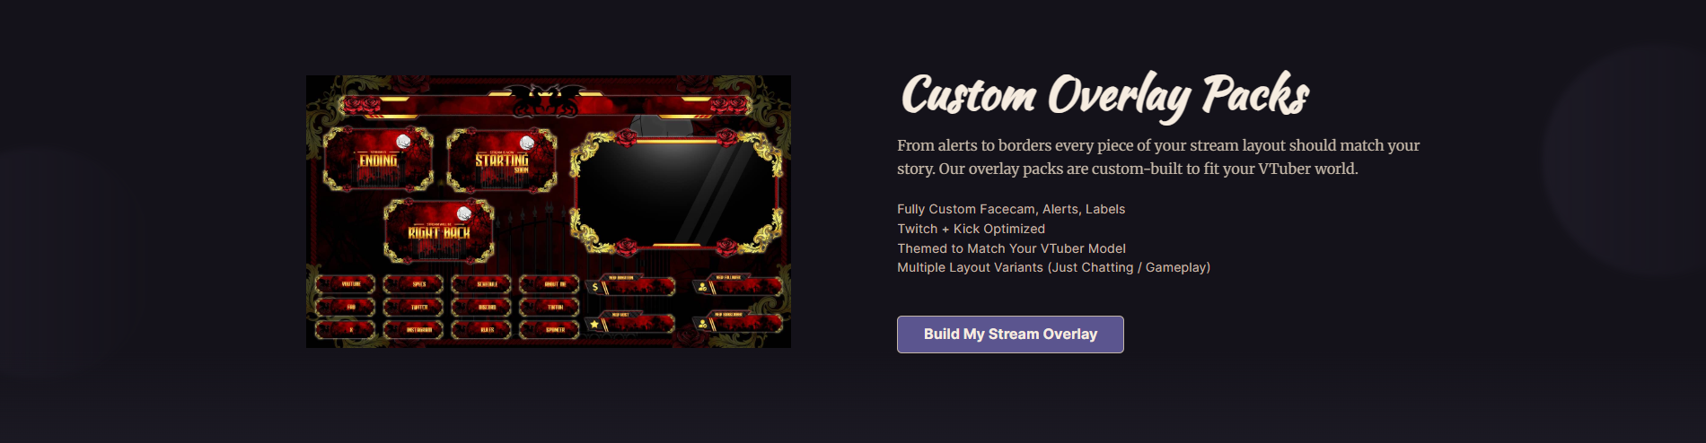
Remove this section

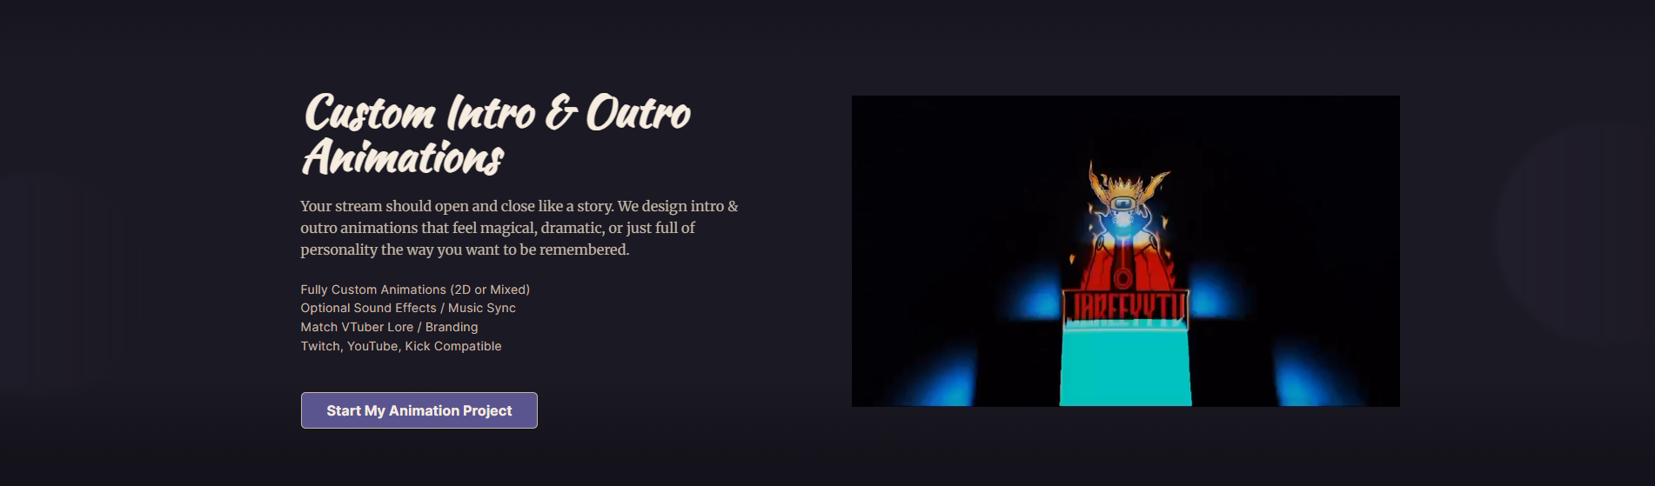
Heading: Intro / Outro Animation
Description: Short animated visuals made for stream openings, endings, debuts, transitions, or lore moments. We build the animation around your character’s mood, theme, and atmosphere so it feels like part of your world, not just a random animated screen.
Bullets:
Designed around your character theme and lore
Great for openings, endings, debuts, and transitions
Can include 2D or 3D-style scene direction
Prepared for Twitch, YouTube, Kick, OBS, or Streamlabs
Button: Create My Animation
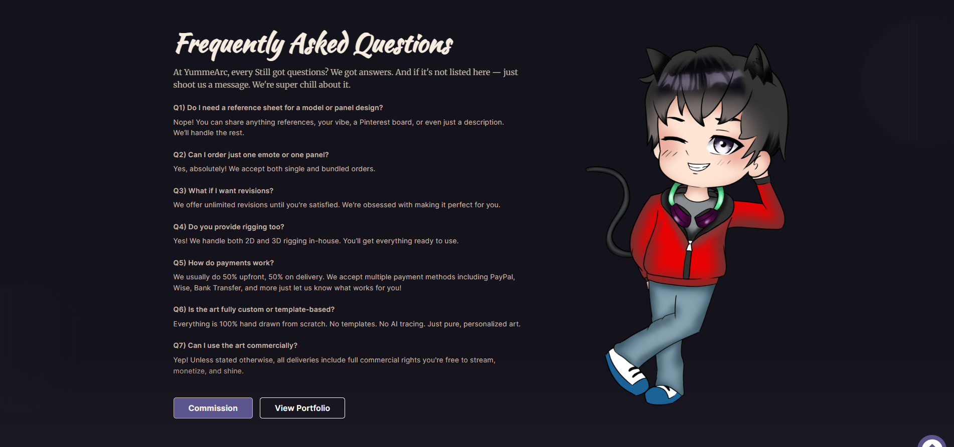
Heading: Frequently Asked Questions
Description: Not sure how the process works yet? Here are a few things creators usually ask before starting a project with YumeArc.
Do I need a full reference sheet to start?
No. You can send lore, moodboards, Pinterest boards, screenshots, rough notes, or even just a description. We can help shape the visual direction from there.
Can I order just one emote, panel, or asset?
Yes. You can order a single asset or build a full custom package around your model and stream identity.
What if my idea still feels messy?
That’s completely fine. A lot of creators come to us with scattered references or a feeling they can’t fully explain yet. We’ll help clarify the direction before moving into the final artwork.
Do you offer rigging too?
Yes, we can help with Live2D and 3D rigging depending on the project. We’ll confirm what’s included before starting.
How do payments usually work?
Most projects start with an upfront payment, with the remaining balance handled before final delivery. Payment details can depend on the project size, and we can discuss what works best before starting.
Is the work custom or template-based?
Our work is made around your character, lore, references, and stream needs. We don’t want your assets to feel like something anyone else could use.
Can I use the art commercially?
Most projects include commercial use for streaming and content creation unless something different is discussed before starting. We’ll make the usage clear before the project begins.
Buttons:
Start a Project
See the Portfolio

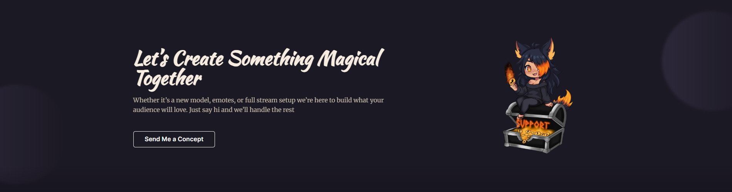
Heading: Still figuring out your character direction?
Description: You don’t need every detail figured out before reaching out. If you have lore, references, a current model, or even just a messy idea, we can help shape the direction and figure out what fits your character best.
Button: Start With Your Idea

Commission Page

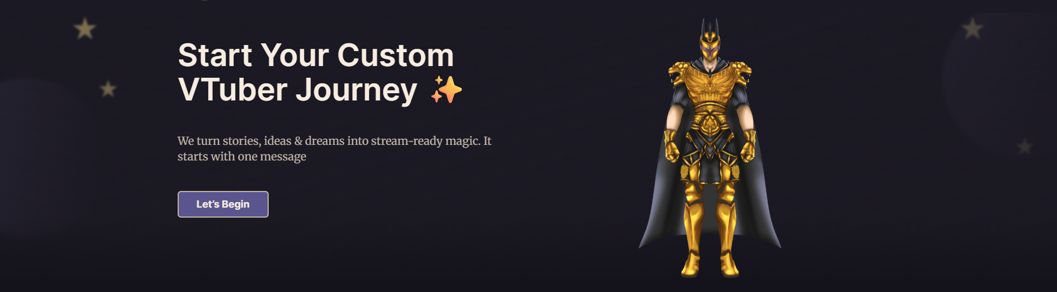
Headline: Start with the idea, even if it’s messy.
Description: Tell us about your character, lore, references, current model, or just the feeling you want. We’ll help clarify the direction first, then guide you toward the right model, panels, emotes, or stream visuals.
Button: Start Your Request

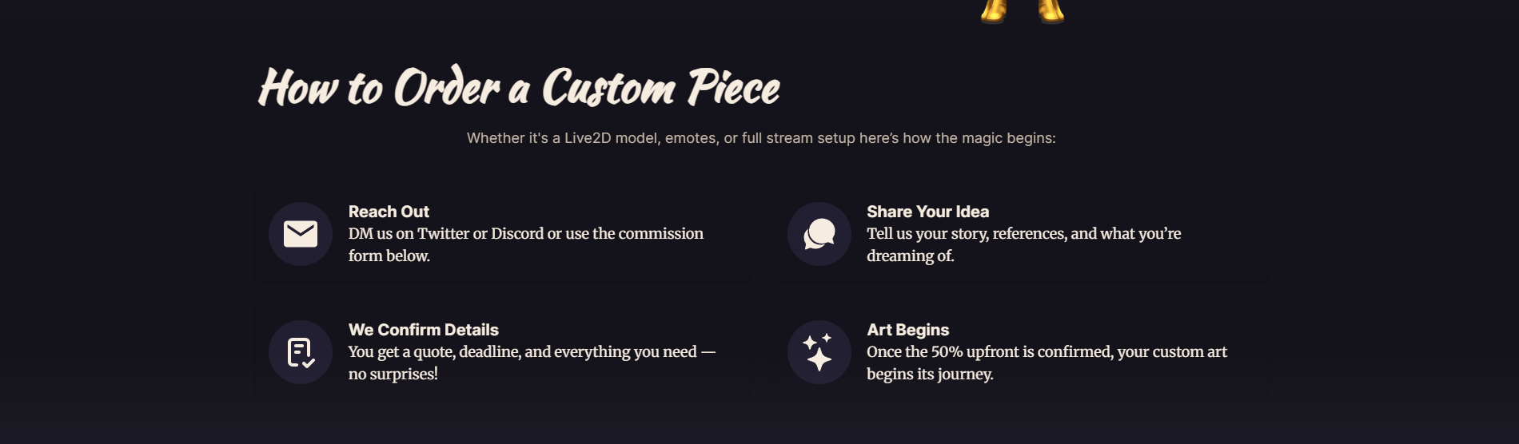
Headline: How we start your project
Description: You don’t need everything perfectly planned before reaching out. Send what you have, and we’ll help shape the direction from there.
Reach out
Send us a message through Discord, X / Twitter, or the request form.
Share what you have
Lore, references, current model, moodboards, rough notes, or just the feeling you want your character to give off.
We clarify the direction
We talk through the details, suggest what fits, and confirm the service, price, timeline, and next steps.
Project begins
Once the upfront payment is confirmed, we start with the agreed direction and keep you updated through the process.

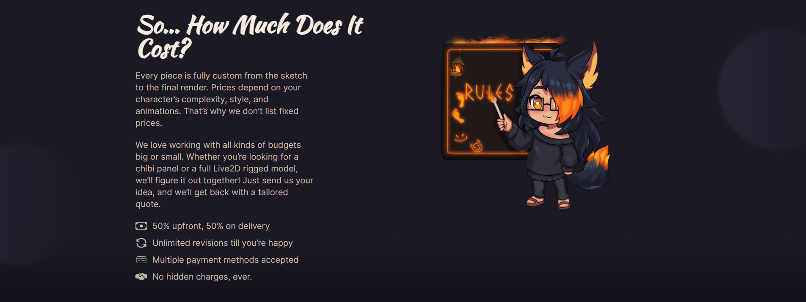

Headline: So... how much does it cost?
Description: Every project is different, so we don’t use one fixed price for every model, panel, or stream asset. The final quote depends on the style, complexity, number of assets, rigging, animation, and how much direction we need to help shape.
Before anything starts, we’ll confirm the scope, price, timeline, and what’s included, so you know exactly what you’re paying for. If you have a budget in mind, you can share it with us and we’ll tell you what makes the most sense within that range.
Bullets:
Clear quote before starting
Usually 50% upfront and 50% before final delivery
Revision rounds included during the agreed stages
Payment options discussed before the project begins
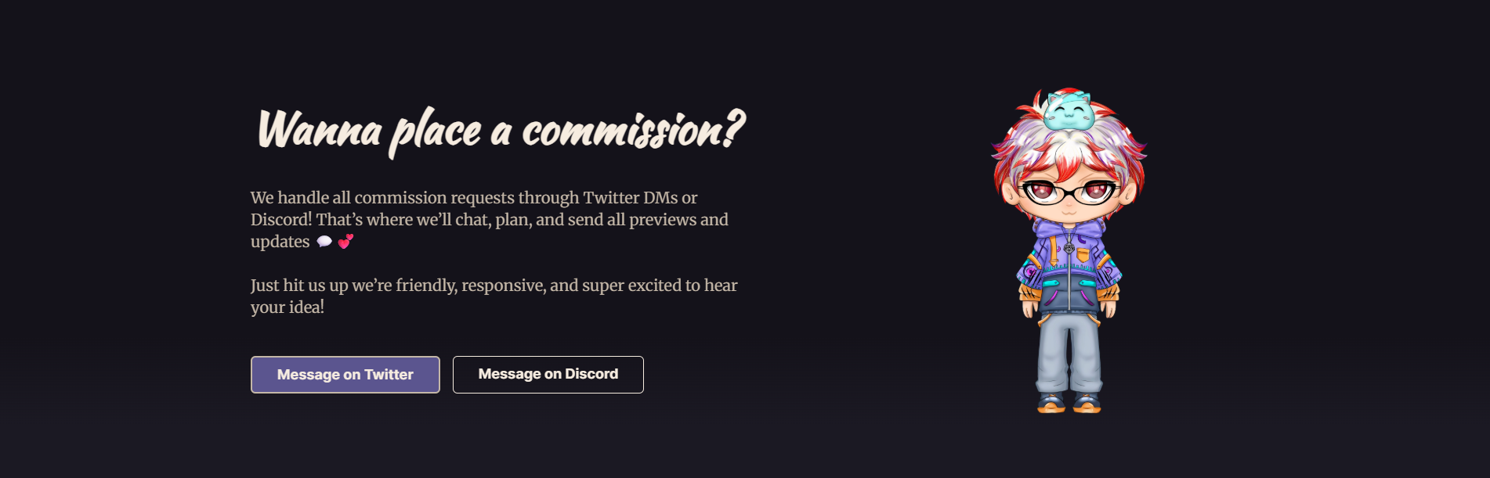
Headline: Ready to talk through your idea?
Description: Reach out through Discord or X / Twitter and send whatever you have so far: lore, references, a current model, a rough idea, or the feeling you want. We’ll help clarify the direction before giving you the next steps.
Buttons:
Message on Discord
Message on X / Twitter

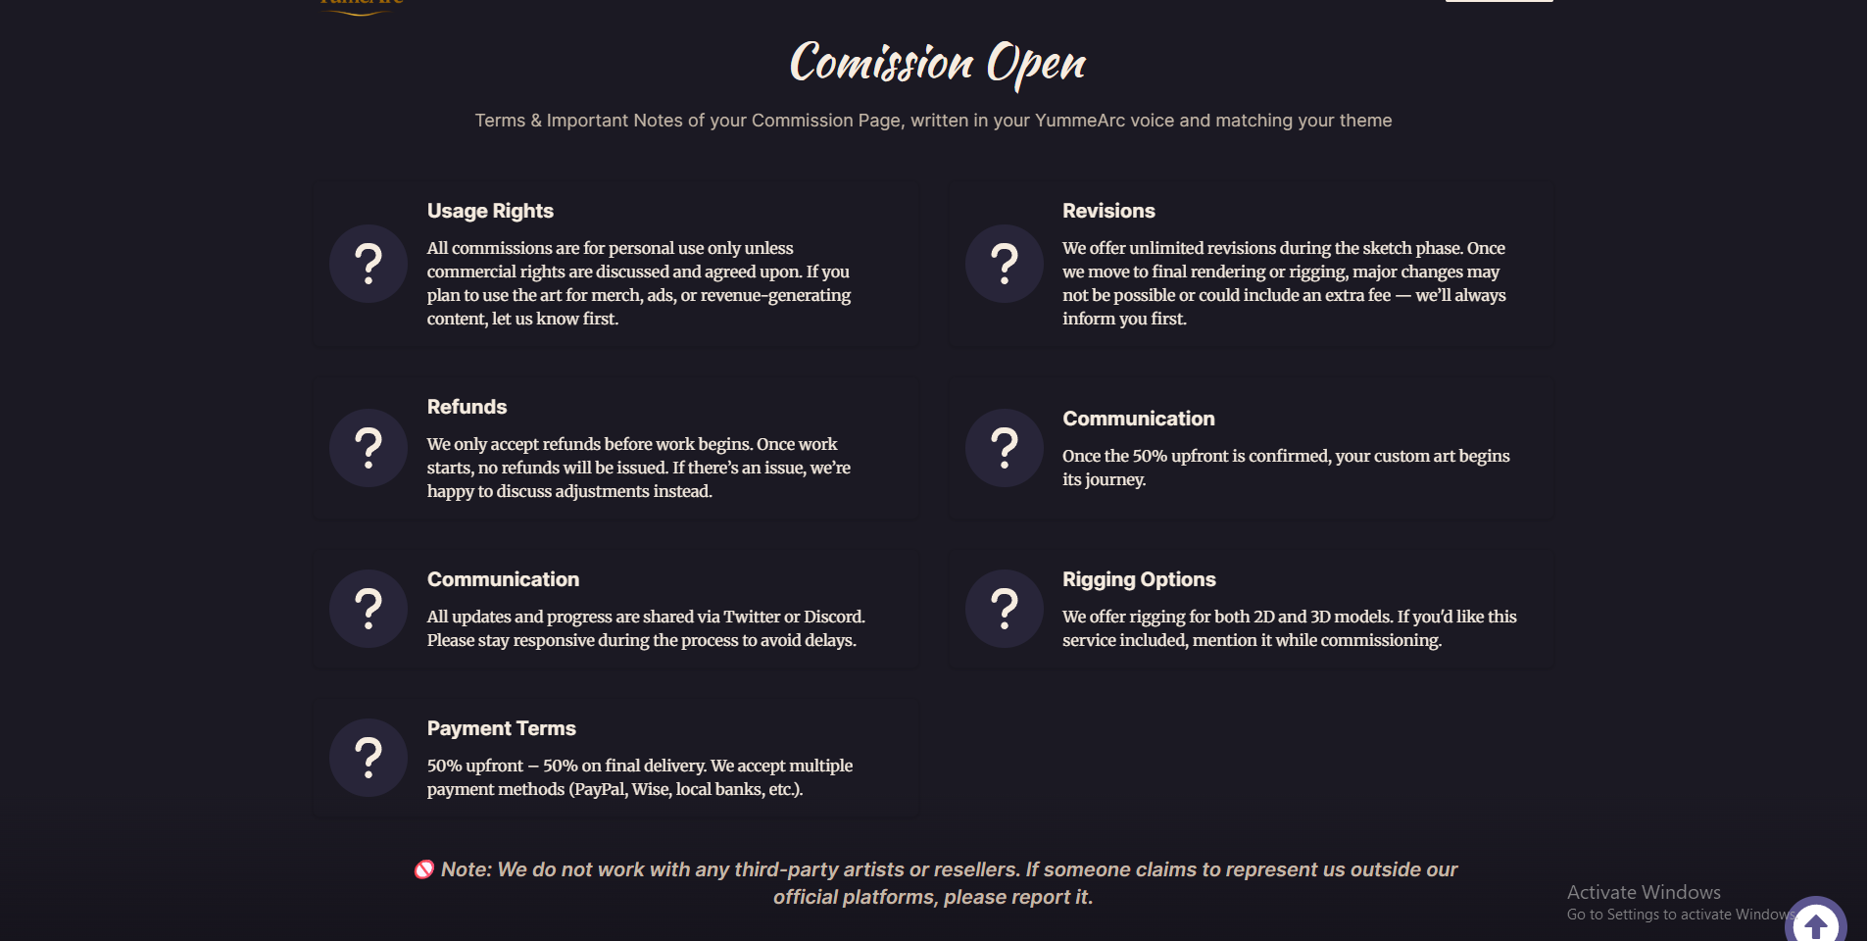
Heading: Before we start your commission
Subtext: A few simple notes so the process stays clear, fair, and comfortable for both sides.
Card 1
Usage rights
Personal use is included by default. If you plan to use the art for merch, ads, paid content, or larger commercial use, let us know before we start so we can confirm the rights clearly.
Card 2
Revisions
Revision rounds are included during the agreed stages. Big changes after sketch approval, final rendering, or rigging may affect the timeline or cost, but we’ll always tell you first.
Card 3
Refunds
Refunds can be discussed before work begins. Once the project has started, refunds are usually not available, but if something goes wrong, we’ll talk through the best way to handle it.
Card 4
Project start
Your project starts once the scope, price, timeline, and upfront payment are confirmed.
Card 5
Updates
Progress and previews are shared through Discord or X / Twitter. Staying responsive helps us avoid delays and keep the project moving smoothly.
Card 6
Rigging options
We can help with Live2D and 3D rigging depending on the project. If you need rigging included, mention it when you send your request.
Card 7
Payment terms
Most projects are split into 50% upfront and 50% before final delivery. Available payment methods can be confirmed before starting.

Safety note: YumeArc only works through our official Discord, X / Twitter, website, and listed team members. If someone claims to represent us outside our official platforms, please check with us before sharing project details or making payment.

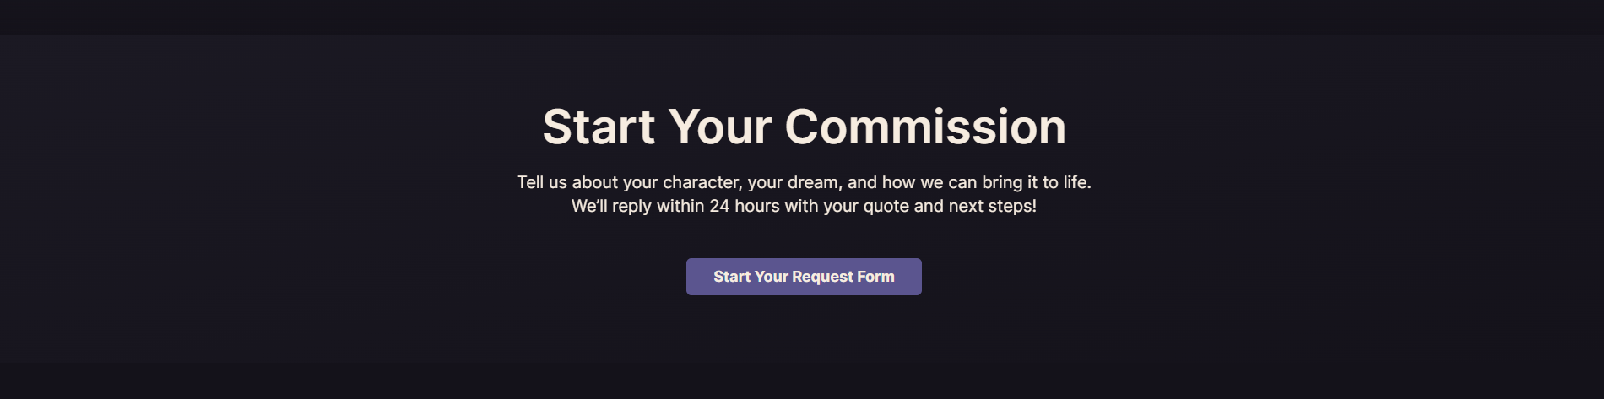
Headline: Ready to share your idea?
Description: Send us your lore, references, current model, rough notes, or just the feeling you want your character to have. We’ll review it, help clarify the direction, and send the next steps.
Button: Send Your Request

PORTFOLIO PAGE
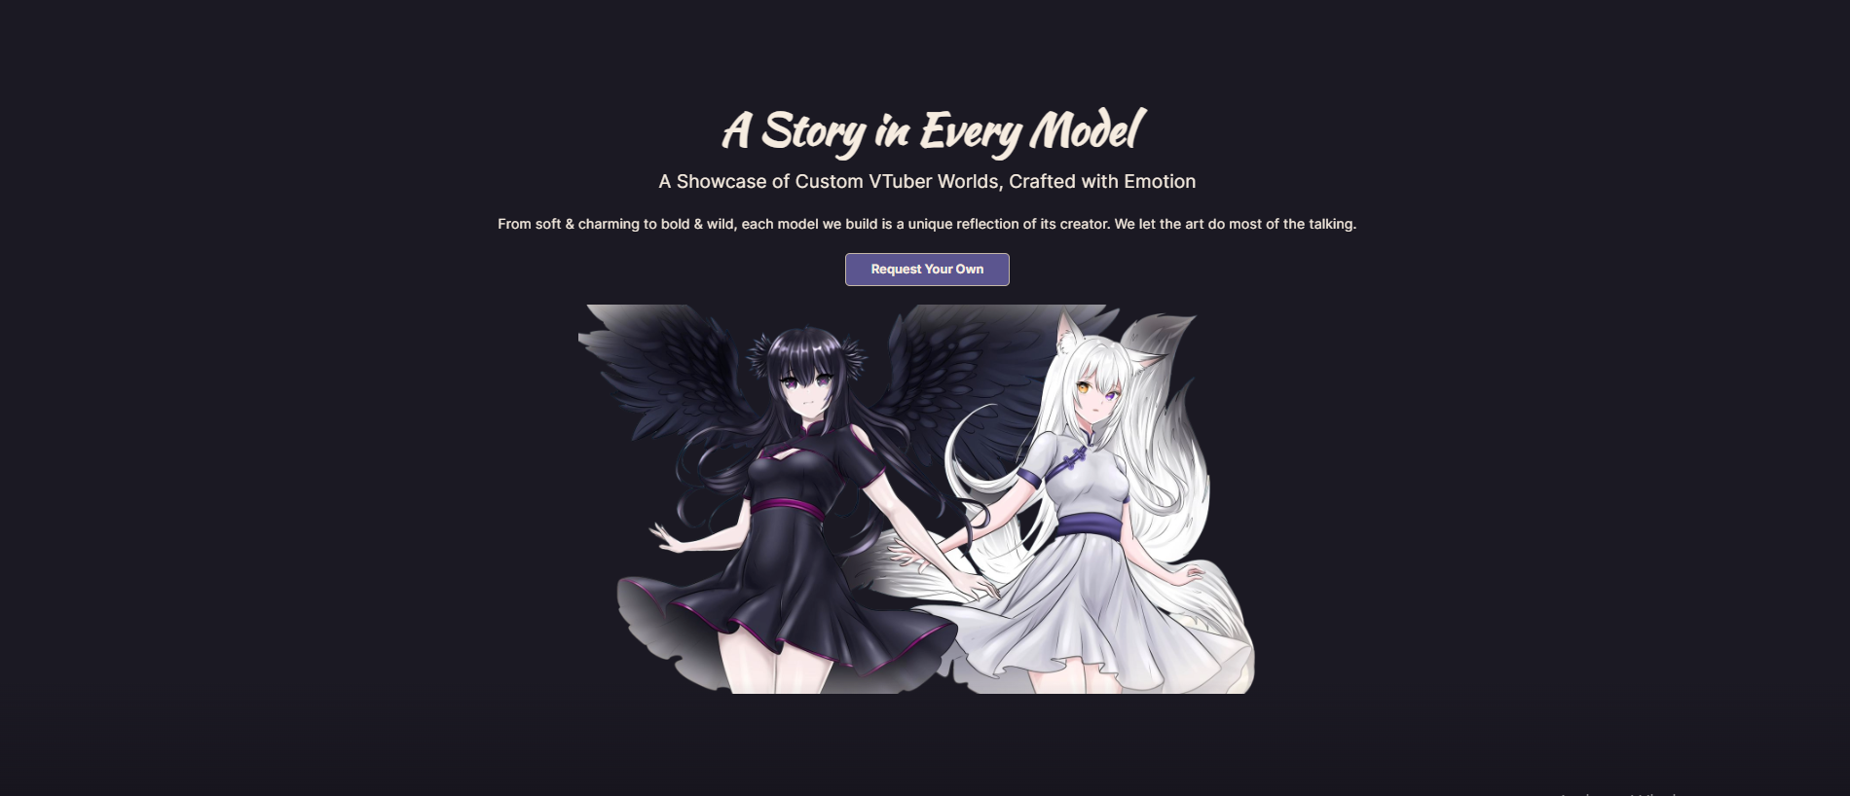
Headline: Every piece starts with a character.
Description: Explore custom models, chibi panels, emotes, PFPs, stream scenes, and visual assets made to reflect each creator’s lore, personality, and visual direction.
Button: Start Your Project

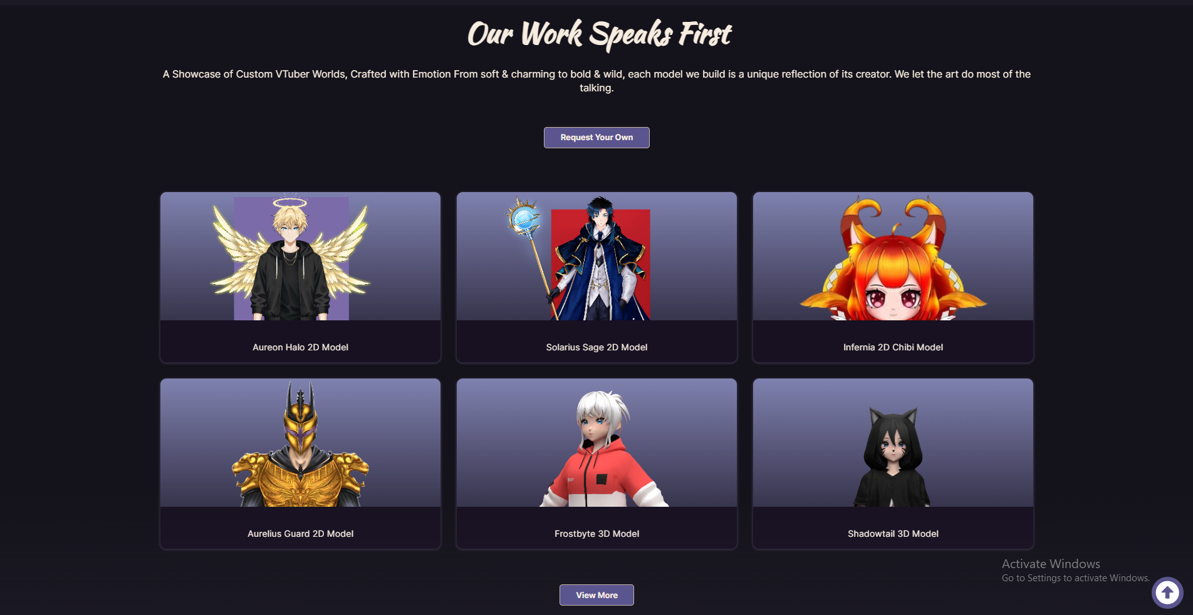

Heading: Models & Character Builds
Description: From Live2D models and chibi versions to 3D avatars and PNGTubers, these are the character builds shaped around each creator’s look, mood, and stream presence.
Button: View More Models
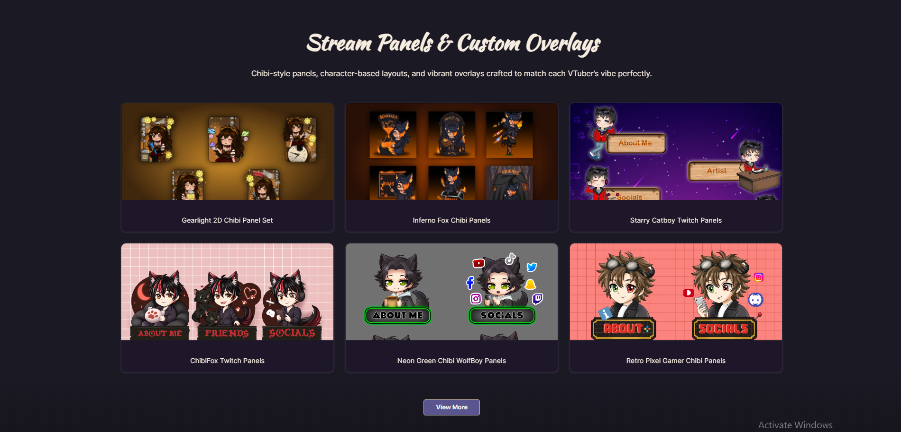
Heading: Stream Identity Assets
Description: Panels, PFPs, emotes, and badges made to keep a creator’s character recognizable across Twitch, Discord, X, YouTube, and their community spaces.
Button: See More Stream Assets
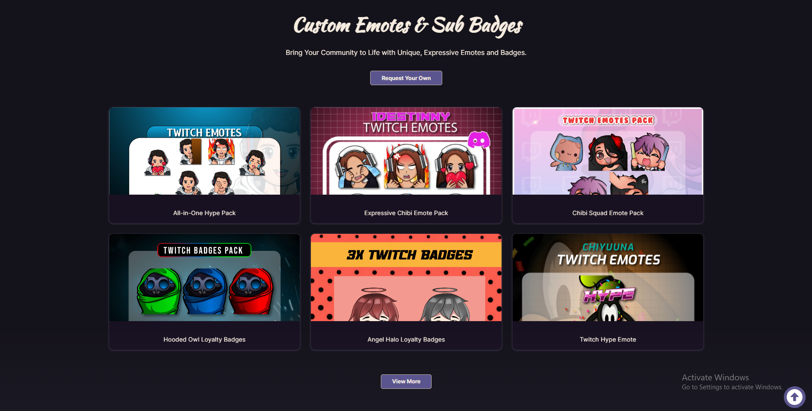
Remove this
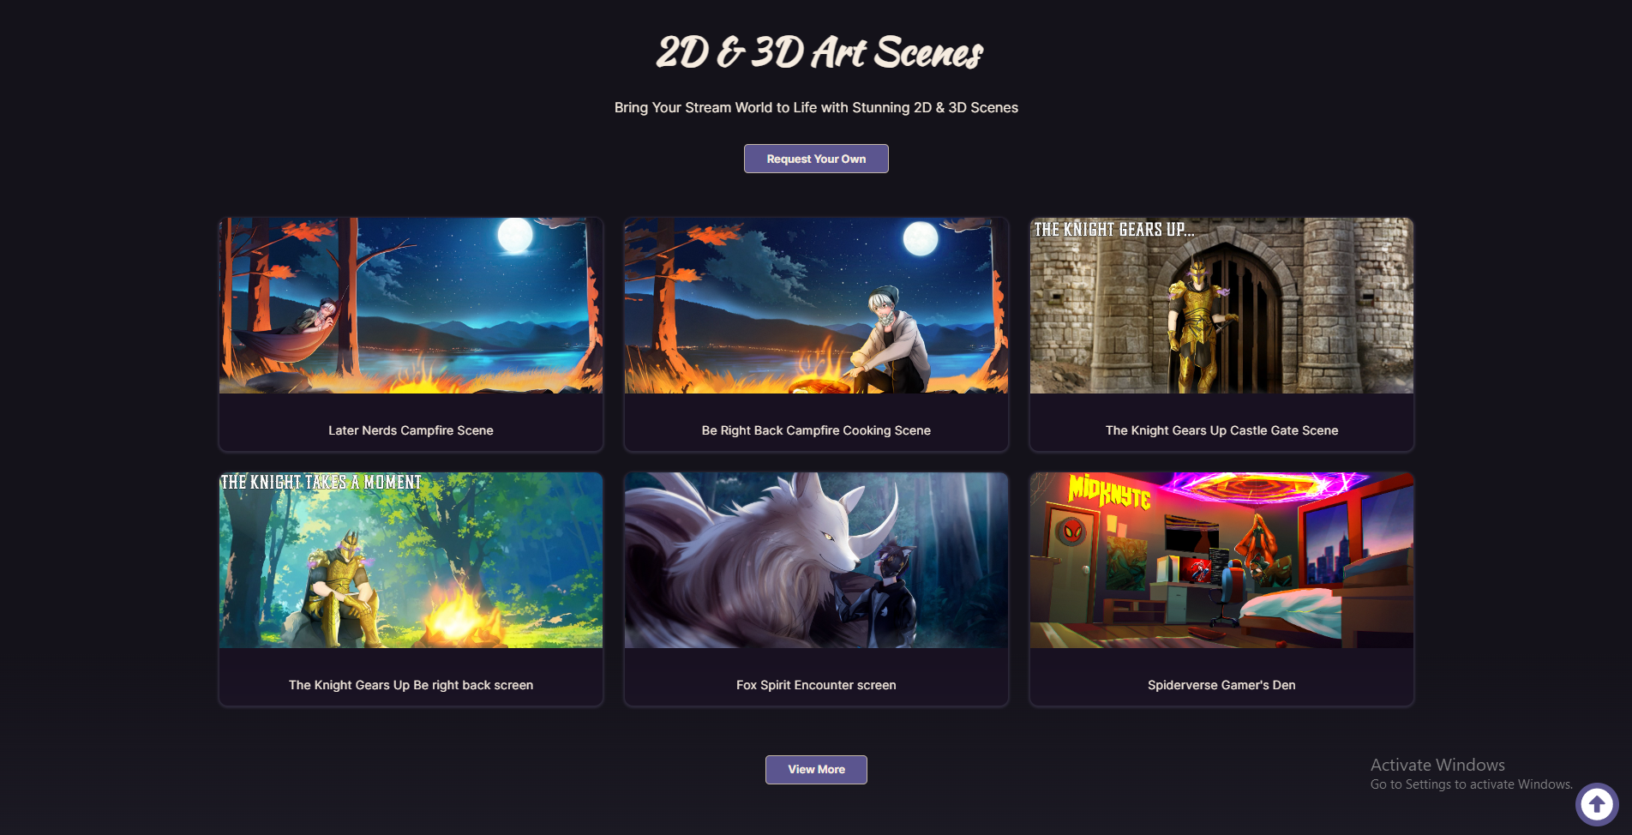
Heading: Scenes, Screens & Motion
Description: Stream scenes and animated visuals built to set the mood before, during, and after the stream, from quiet BRB moments to cinematic lore-based openings.
Button: View More Stream Visuals

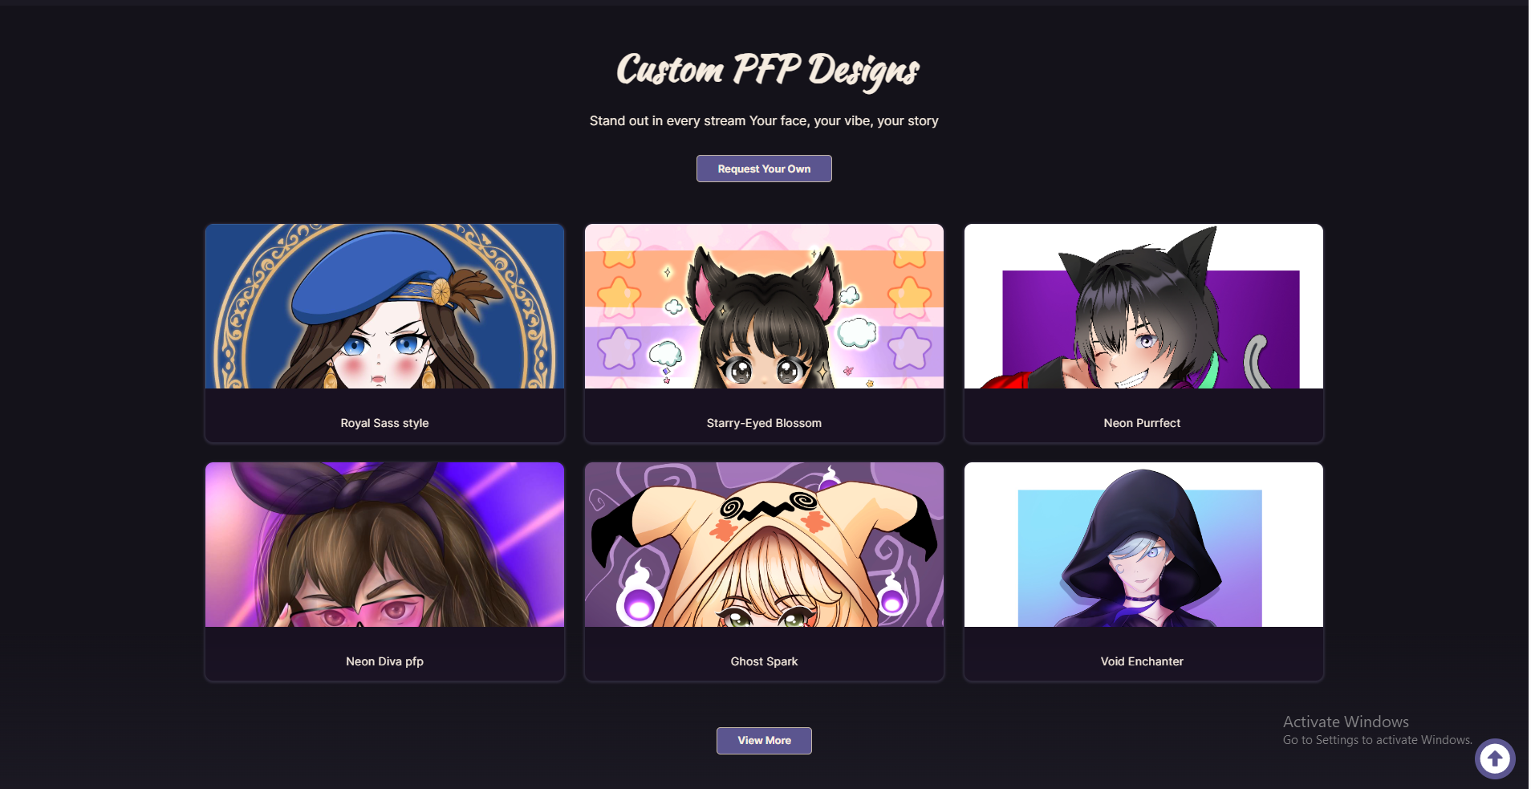
Remove this
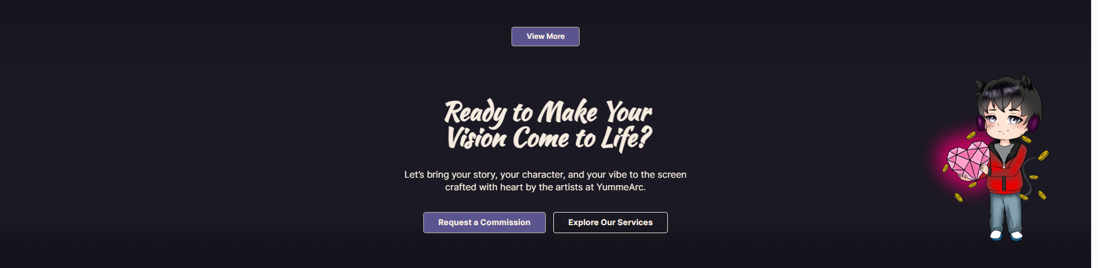
Heading: Want your character to feel this connected too?
Description: Send us your lore, references, current model, or even just the feeling you want your character to have. We’ll help shape the direction and figure out what visual pieces make sense for you.
Button: Start Your Project

